- First of all, the language of the Android Tablet need to change from Spanish to English.
Double check System setting ---- language ----English
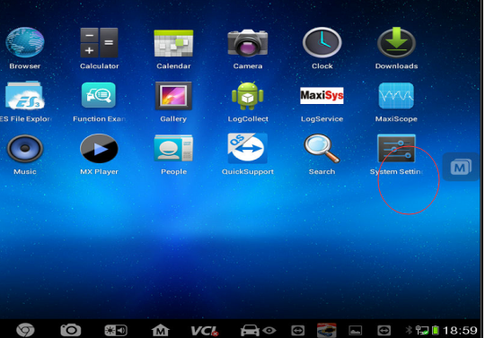

- The language of Diagnostic need to change.
To change the language from Spanish to English.

Step 1: Click at Maxisys.
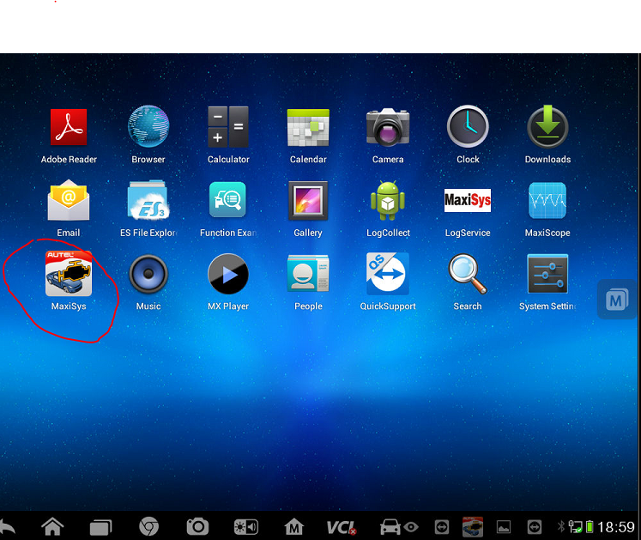

Step 2: Click at “Settings”.
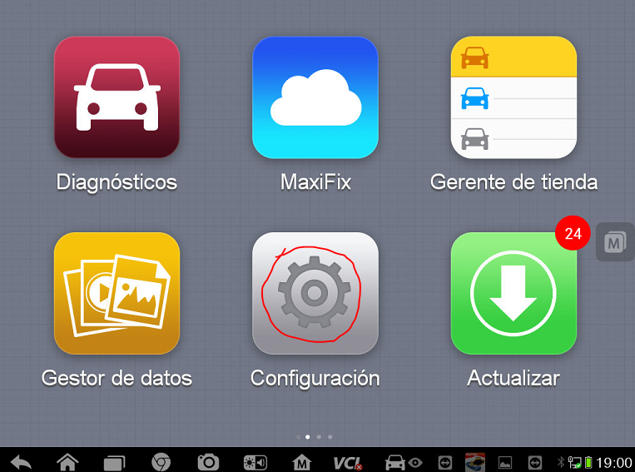
Step 3: Click at “ Language”

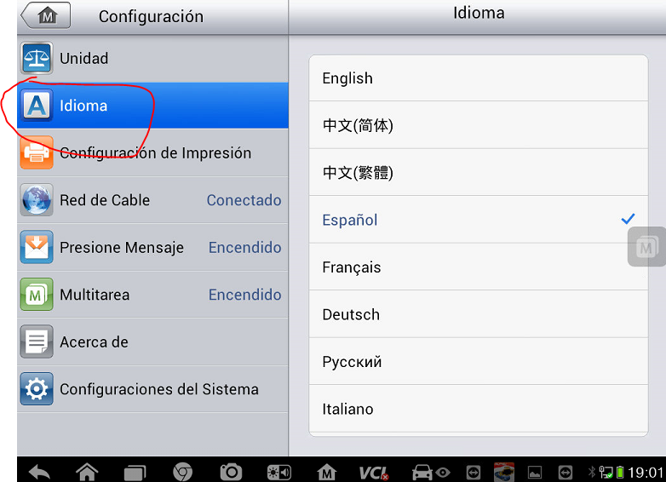

Step 4: Select “ English”
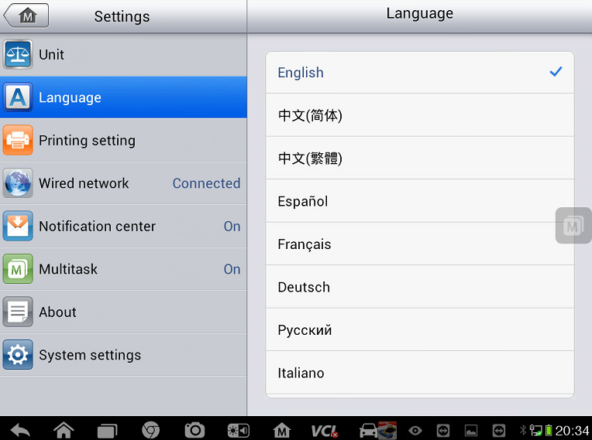

Then you can see that the language is in English now.
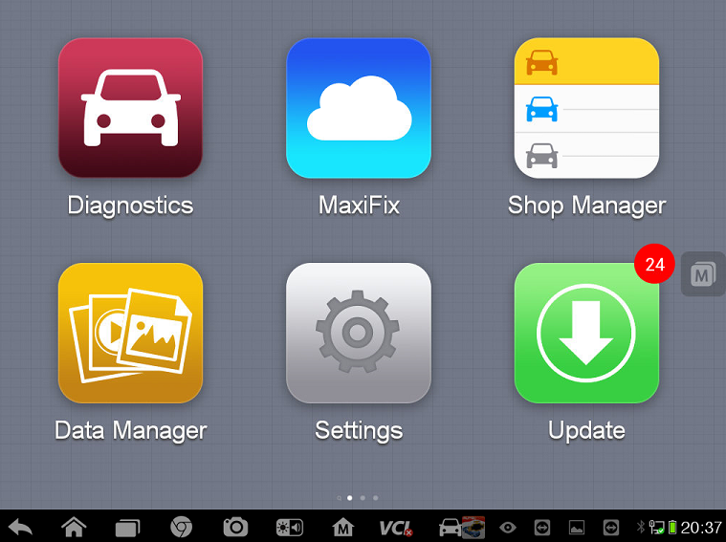
After changing language to English and if you found it is blank here(Maxisys---Diagnostic).
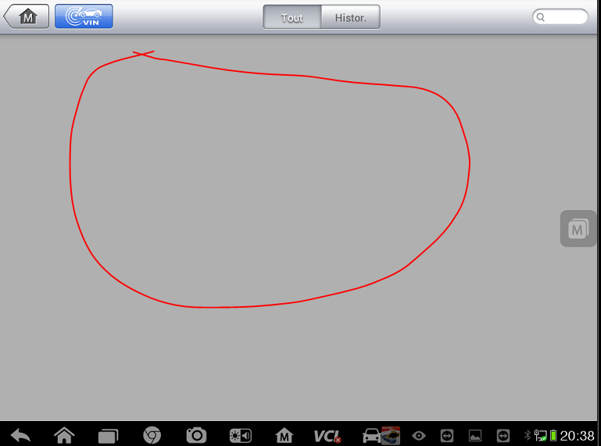

Please go to Update and select vehicles software and reload them.
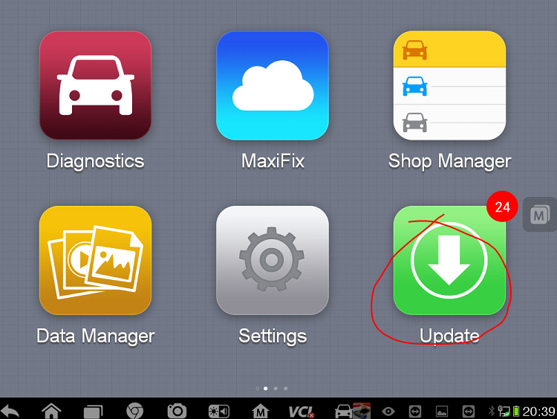

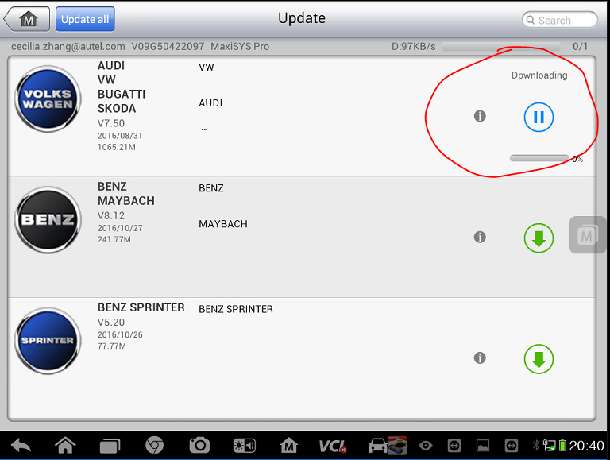
If you have any other question about Autel serial scanner, please contact us via sales@obd2tool.com

